

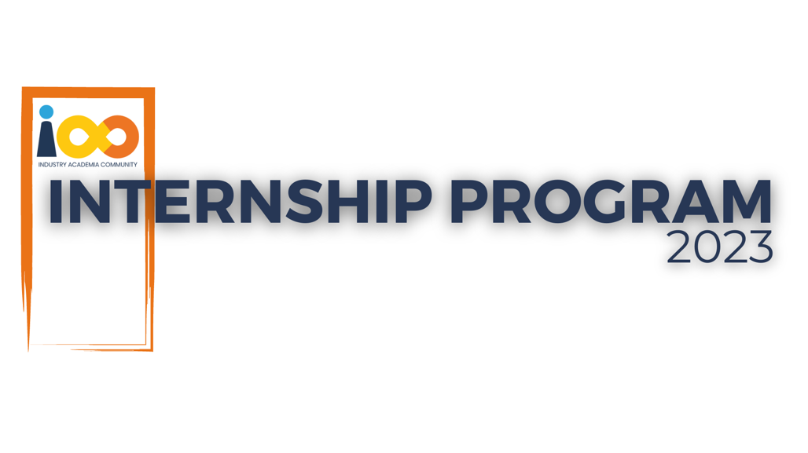

PROJECT REPORT

JAVA  
  
IAC ‘COMMUNITY AMBASSADOR ONBOARDING PROCESS’

|  |  |  |  |
| --- | --- | --- | --- |
| **Created By:** | Guguloth Rajkumar | **Approved By:** | Harshada Topale |
| **Created On:** | 24-04-2025 | **Approved On:** | 24-04-2025 |

Page left blank intentionally

**INDEX**

**1** **PROJECT DETAILS** 2

**2** **SUMMARY** 2

**3** **INTRODUCTION** 2

3.1 Background 2

3.2 Stakeholders 2

3.3 Objectives 2

**4** **METHODOLOGY** 2

4.1 Considerations & Assumption 3

4.2 Approach 3

4.3 Activities 3

**5** **TARGETTED V/S ACHIEVED OUTPUT** 3

**6** **CONCLUSION** 3

**7** **APPENDICES** 4

7.1 Appendix A – Title 4

**General Instructions for using the Live Project Report Template**

* This template and the subsequent document created using this template is a confidential document and is the intellectual property of Cloud Counselage Pvt. Ltd. Circulating it outside of the organisation without the consent of Cloud Counselage Pvt. Ltd. is the breach of company policies and will lead to legal actions
* This template is a guideline document to communicate the implementation of design ideas and the results of the work to the stakeholders.
* The **text between inequality (< >) is to be replaced** by relevant text
* Please **remove the yellow highlight on the Text** between the inequality (< >). This is done to help you notice the text to be changed/replaced
* The text in *italics* highlighted in grey is just for reference and should be removed after adding the relevant text

# **PROJECT DETAILS**

|  |  |  |  |
| --- | --- | --- | --- |
| **Project Name** | IAC ‘Community Ambassador Onboarding Process’ | | |
| **Project Sponsor** | Tushar Topale | | |
| **Project Manager** | Harshada Topale | | |
| **Start Date** | 24-04-2025 | **Completion Date** | 25-04-2025 |

# **SUMMARY**

The Community Ambassador Management System project aimed to streamline the registration, tracking, and monitoring of ambassadors working on promotional campaigns. The system allows the admin to view sign-up metrics, manage user data, and track performance through a centralized dashboard. The need arose due to the lack of a structured platform for ambassador data collection and performance analysis. This system provides long-term benefits by automating user registration, improving data integrity, and offering real-time visibility into campaign effectiveness.

# **INTRODUCTION**

## Background

Many organizations utilize community ambassadors to promote their offerings, but managing ambassador performance and communication manually leads to inefficiencies. This project addressed the need for a centralized web platform to manage user data, automate UTM link tracking, and generate insights for better decision-making. The requirement elicitation session confirmed the need for a web-based solution with email integration and secure admin access.

## Stakeholders

* Process Owner- Tushar Topale
* Key Stakeholders – Harshada Topale
* End Customer – Cloud Counselage Pvt. Ltd.
* Project Developer – Guguloth Rajkumar

## Objectives

* To develop a centralized web platform to register community ambassadors.
* To provide auto-generated UTM links for user tracking.
* To allow the admin to monitor sign-ups and performance metrics.
* To implement role-based access control for user and admin login.
* Objective remained unchanged throughout the project and were successfully achieved.

# **METHODOLOGY**

These conventions are all about the positions of line breaks, how many characters should go on a line, and everything in between.

## Considerations & Assumption

* Oracle database was used as per developer's preference.
* Email integration was set up with standard SMTP services.
* Assumed consistent internet connectivity for end-users.
* Deployment was considered optional due to project guidelines.

## Approach

We followed the Agile model with weekly iterations. Each phase (requirement, design, development, testing, closure) was carefully planned and executed using best practices in full-stack development.

## Activities

* Requirement Elicitation
* Project Planning (Schedule, WBS, RAID)
* Design and Documentation
* Application Development
* Testing and Reporting
* Final Documentation and Project Submission

# **TARGETTED V/S ACHIEVED OUTPUT**

|  |  |
| --- | --- |
| **TARGETTED OUTPUT** | **ACHIEVED OUTPUT** |
| User Registration Module | Fully Implemented |
| UTM Link Auto-generation | Fully Functional |
| Admin Dashboard with metrics | Completed with signup insights |
| Auto-generation Link Increment | Incremented when clicking the UTM link |
| Testing | Fully Implemented with Unit Testing |
| Deployment | Skipped as per the optional clause |

# **CONCLUSION**

The project successfully addressed the inefficiencies in ambassador data handling and campaign tracking. It enables the admin to monitor user activity and gain actionable insights through a secure and responsive web interface. Future improvements could include deploying the application to a live server, adding data export features (PDF/Excel), and integrating real-time analytics.

# **APPENDICES**

## Appendix A – Title

|  |  |  |  |  |  |  |  |
| --- | --- | --- | --- | --- | --- | --- | --- |
| Identification | Type | Purpose | Dependencies | Interfaces | Resources | Processing | Data |
| Registration Module | UI + Backend | Ambassador Signup | Frontend | Email API | Spring Boot App | Form Submission | Oracle DB |
| Dashboard Module | Admin Panel | Monitor Signup Performance | DB |  | Spring Boot | Data Display | Oracle DB |
| Email Integration | Service Layer | Send Registration Confirmation | SMTP Server | Email | Java Mail Sender | |  |  | | --- | --- | |  | Email Logic | | SMTP Server Config |
| Security Layer | Middleware | Admin/User Login Authentication | Spring Sec | Login UI | Spring Security | |  |  | | --- | --- | | Authentication |  | | Role-based Access |
| UTM Link Generator | Utility | Generate unique links for tracking | Backend |  |  | ID Creation | Oracle DB |